**SSN College of Engineering, Chennai**

**UCS 2611 Internet Programming Lab**

**Exercise 1: Implementation of Conference Website using HTML**

**Date of Exercise: 30.01.2024**

1. Create the following sample web page using necessary HTML elements

**Program code:**

**Index1.html**

<!DOCTYPE html>

<html>

    <head><title>Assignment-1</title></head>

    <body>

        <p style="color:blue;">Sample Webpage</p>

        <br>

        Header elements

        <h1>SSN College of Engineering</h1>

        <h2>SSN College of Engineering</h2>

        <h3>SSN College of Engineering</h3>

        <h4>SSN College of Engineering</h4>

        <h5>SSN College of Engineering</h5>

        <h6>SSN College of Engineering</h6>

        <hr>

        Paragraph element

        <p>This is Praba working as Asso. Prof. in SSN College of Engineering</p>

        <hr>

        Pre element

        <pre>

            This is Praba

            working as Asso. Prof.

            in SSN College of Engineering

        </pre>

        <hr>

        Ordered list

        <ol type="i">

            <li>One</li>

            <li>Two</li>

            <li>Three</li>

        </ol>

        Unordered list

        <ul>

            <li>One</li>

            <li>Two</li>

            <li>Three</li>

        </ul>

        Definition lists

        <dl>

            <dt>Coffee</dt>

            <dd>Hot Drink</dd>

            <dt>Juice</dt>

            <dd>Cool Drink</dd>

        </dl>

        <hr>

        Anchor Element <a href="#Linked List">Linked List</a>

        <hr>

        Destination Anchor element

        <br>

        Array

        <pre>

            An

            array

            is a collection of

            items stored at

            contiguous memory locations.

            Items of the same type together.

            This makes it easier to

            calculate the position of each element

            by simply adding an offset to  a base value, i.e., the memory location of the first element of the array

        </pre>

        <p id="Linked List">

        Linked list

        <pre>

            Linked

            List

            is

            a

            linear

            data structure,

            in which elements are not stored

            at a contiguous location, rather they are linked

            using pointers. Linked list forms a series of connected nodes,

            where each node stores the data and the address of the next node.

        </pre>

        </p>

    </body>

</html>

**Output:**

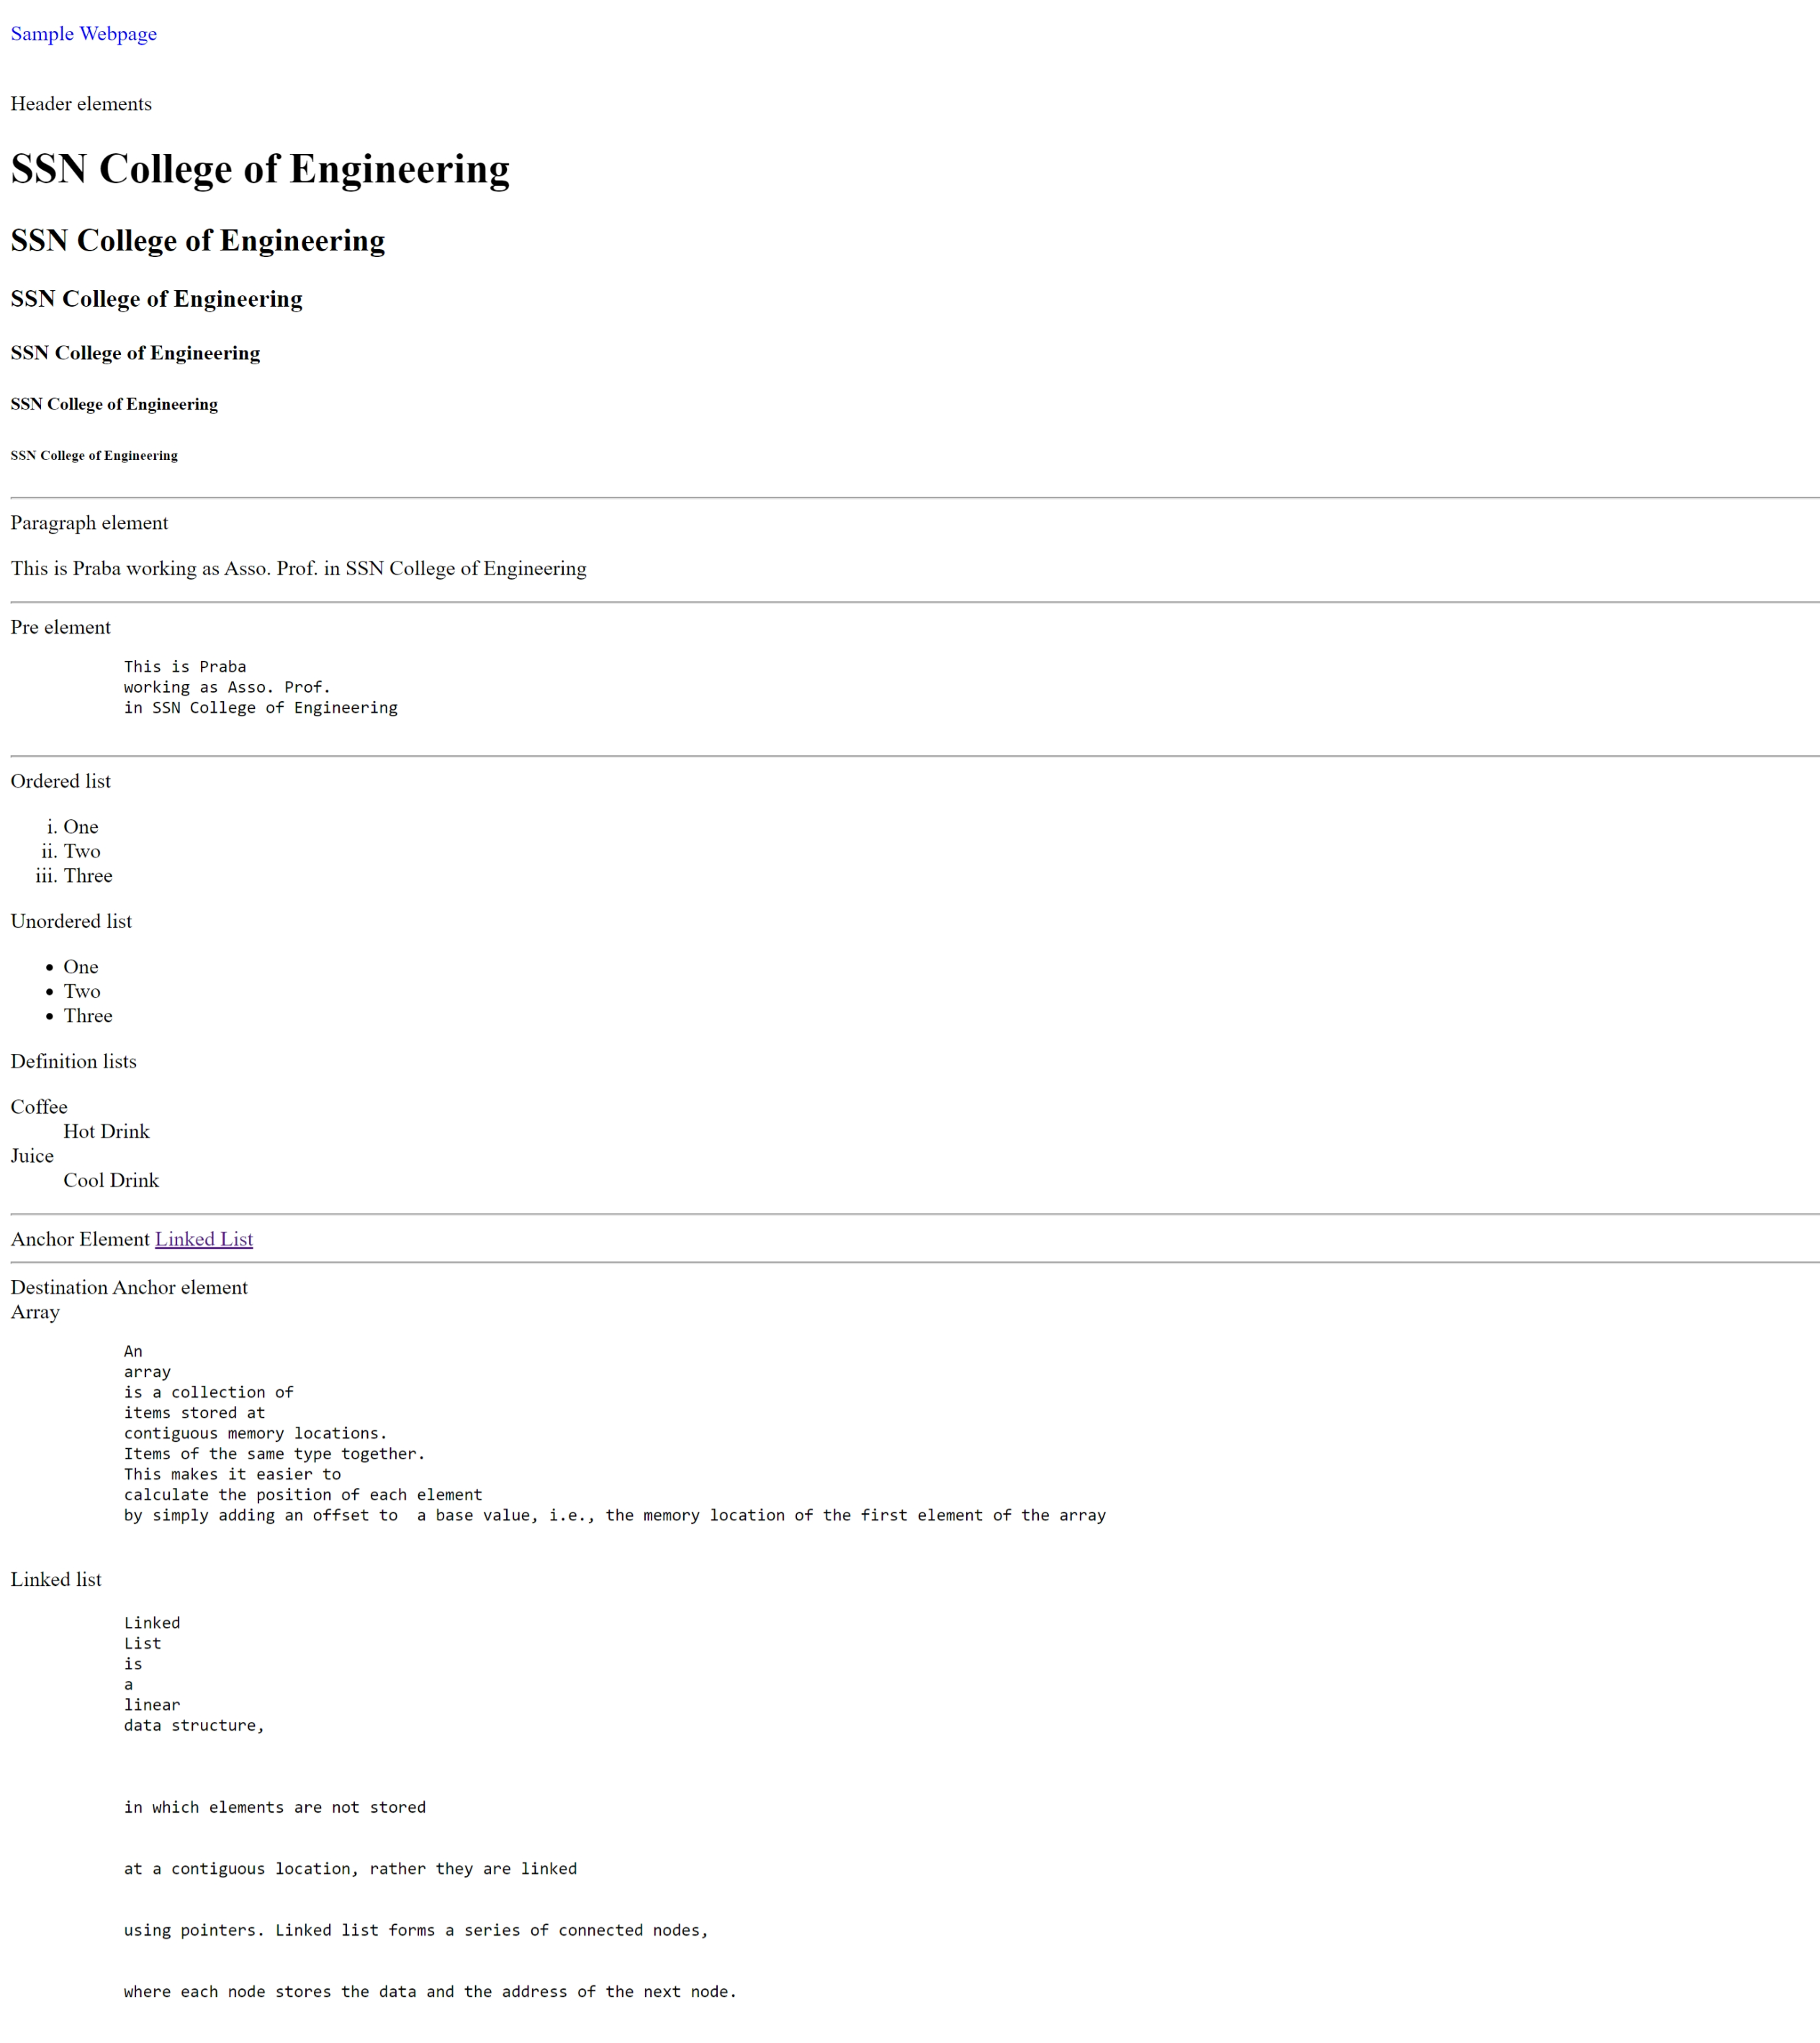

**Program code:**

**ICCIDS.html**

<html>

    <head>

        <title>ICCIDS 2024</title>

    </head>

    <body>

        <div>

            <a href="home.html" target="_self">Home</a>

            &emsp14; &emsp14; &emsp14; &emsp14;

            <a href="#About" target="_self">About</a>

            &emsp14; &emsp14; &emsp14; &emsp14;

            <a href="#Committee" target="_self">Committee</a>

            &emsp14; &emsp14; &emsp14; &emsp14;

            <a href="#Speakers" target="_self">Speakers</a>

            &emsp14; &emsp14; &emsp14; &emsp14;

            <a href="#Call for papers" target="_self">call for papers</a>

            &emsp14; &emsp14; &emsp14; &emsp14;

            <a href="#Venue" target="_self">Venue</a>

            &emsp14; &emsp14; &emsp14; &emsp14;

            <a href="#Contact" target="_self">Contact</a>

        </div>

        <center>

            <div>

                <h1>ICCIDS 2024</h1>

                <h2>7th International Conference on Computational Intelligence in Data Science</h2>

                <h3>February 21-23,2024</h3>

                Department of Computer Science and Engineering

                <br><br>

                Sri Sivasubramaniya Nadar College of Engineering

                <br><br>

                Rajiv Gandhi Salai (OMR), Chennai, Tamil Nadu, India

            </div>

        </center>

        <hr>

        <h3 id="About">About the Event</h3>

        <p>In 2015, the United Nations set several ambitious sustainable development goals to be achieved in the next 15 years to make our world a better place for everyone: end poverty, protect the planet, and ensure prosperity for all. Towards this objective, the Department of Computer Science and Engineering, Sri Sivasubramaniya Nadar College of Engineering is proud to conduct and organize the ICCIDS 2024-7th International Conference on Computational Intelligence in Data Science on February 21-23, 2024.</p>

        <p>The conference provides an opportunity for researchers, engineers, developers, and practitioners from academia and industry to discuss experimental and theoretical work in solving problems to achieve sustainable development goals through Artificial Intelligence (AI). </p>

        <p>This conference holds value for anyone with an interest in or involvement with Al and its diverse

        applications across various domains. It features expert talks provided by individuals from renowned institutions and organizations across the globe, presentations by young researchers. Notably, accepted papers presented at the conference will be incorporated into the conference proceedings and subsequently published as part of the prestigious Springer IFIP AICT (Advances in Information and Communication Technology) series.</p>

        <hr>

        <h3>Indexing</h3>

        <p>Published Volume will be indexed in -</p>

        <ul>

            <li>Scorpus</li>

            <li>Google Scholar</li>

            <li>Citeseer</li>

            <li>Crossref</li>

        </ul>

        <hr>

        <h3 id="Committee">Committee</h3>

        <center>

            <img src="https://www.ssn.edu.in/wp-content/uploads/2020/08/DrVEAnnamalai_pp_square.jpg" alt="Prof_Annamalai" height="300">

            <img src="https://www.tandfonline.com/cms/asset/d27a6188-671e-4aae-9593-4c1943663d90/tijr_a_1951374_ilg0002.gif" alt="Prof_Radha" height="300">

            <img src="https://www.ssn.edu.in/wp-content/uploads/2020/04/mirnalini.png" alt="Prof_Mirunalini" height="300">

        </center>

        <hr>

        <h3 id="Technical Committee">Technical Committeee</h3>

        <center>

            <table>

                <tr>

                    <td>

                        <p>

                            Dr.Chutisant Kerdvibulvech,<br>

                            Associate Professor, Chulalongkorn<br>

                            University, Thailand<br>

                            Dr.Yanhui Guo, Associate Professor,<br>

                            USA, University of Illinois Springfield<br>

                        </p>

                    </td>

                    <td>

                        <p>

                            Dr. Aarthi Murugesan Krishna,<br>

                            USA<br>

                            Dr. Latha Karthika, CEO,<br>

                            Brandupwise Marketing, New<br>

                            Zealand

                        </p>

                    </td>

                    <td>

                        <p>

                            Mr. Thangmani Paulchamy, CEO,<br>

                            Siva Cerulean Technologies,<br>

                            Atlanta, USA<br>

                            Dr. Sriram Kailasam, IIT Mandi<br>

                        </p>

                    </td>

                </tr>

            </table>

        </center>

        <hr>

        <h3>Editors</h3>

        <center>

            <p>Prof. Mieczysław Lech OWOC, IFIP Vice-Chair, WG 12.6 - Knowledge Management</p>

            <p>Dr. R. Kanchana, Associate Professor, Department of CSE, SSNCE</p>

            <p>Dr. V.S Felix Enigo, Associate Professor, Department of CSE, SSNCE</p>

            <p>Dr. B. Prabavathy, Associate Professor, Department of CSE, SSNCE</p>

        </center>

        <hr>

        <h3>Program Committee</h3>

        <center>

            <p>Prof. Mieczysław Lech OWOC, IFIP Vice-Chair, WG 12.6 - Knowledge Management</p>

            <p>Mr. Dominique Verdejo, IFIP Chair, WG 12.13 - AI Global Security</p>

            <p>Dr. Zahia Guessoum, Université de Reims Champagne-Ardenne</p>

            <p>Dr. Nada Matta, Professor, UTT - Université de technologie de Troyes</p>

            <p>Dr. Eunika Mercier-Laurent, Professor and Chair IFIP TC12(AI), Dept. of Infomatics, University of Reims Champagne-Ardenne, France</p>

        </center>

        <hr>

        <h3>Committee</h3>

        <center>

            <div id="committee">

                <img src="https://i1.rgstatic.net/ii/profile.image/1109608177369090-1641562613941_Q128/Mieczyslaw-Owoc.jpg" alt="1" height="300">

                <img src="https://paws.kettering.edu/~skanchi/welcome_files/image001.jpg" alt="2" height="300">

                <img src="https://encrypted-tbn0.gstatic.com/images?q=tbn:ANd9GcRUHgnKONCBauzALVi9Gq2768jzjrrP2t3dAhtvuNwPGoygq1PY" alt="3" height="300">

            </div>

        </center><br>

        <hr>

        <br><br>

    </body>

</html>

**Output:**

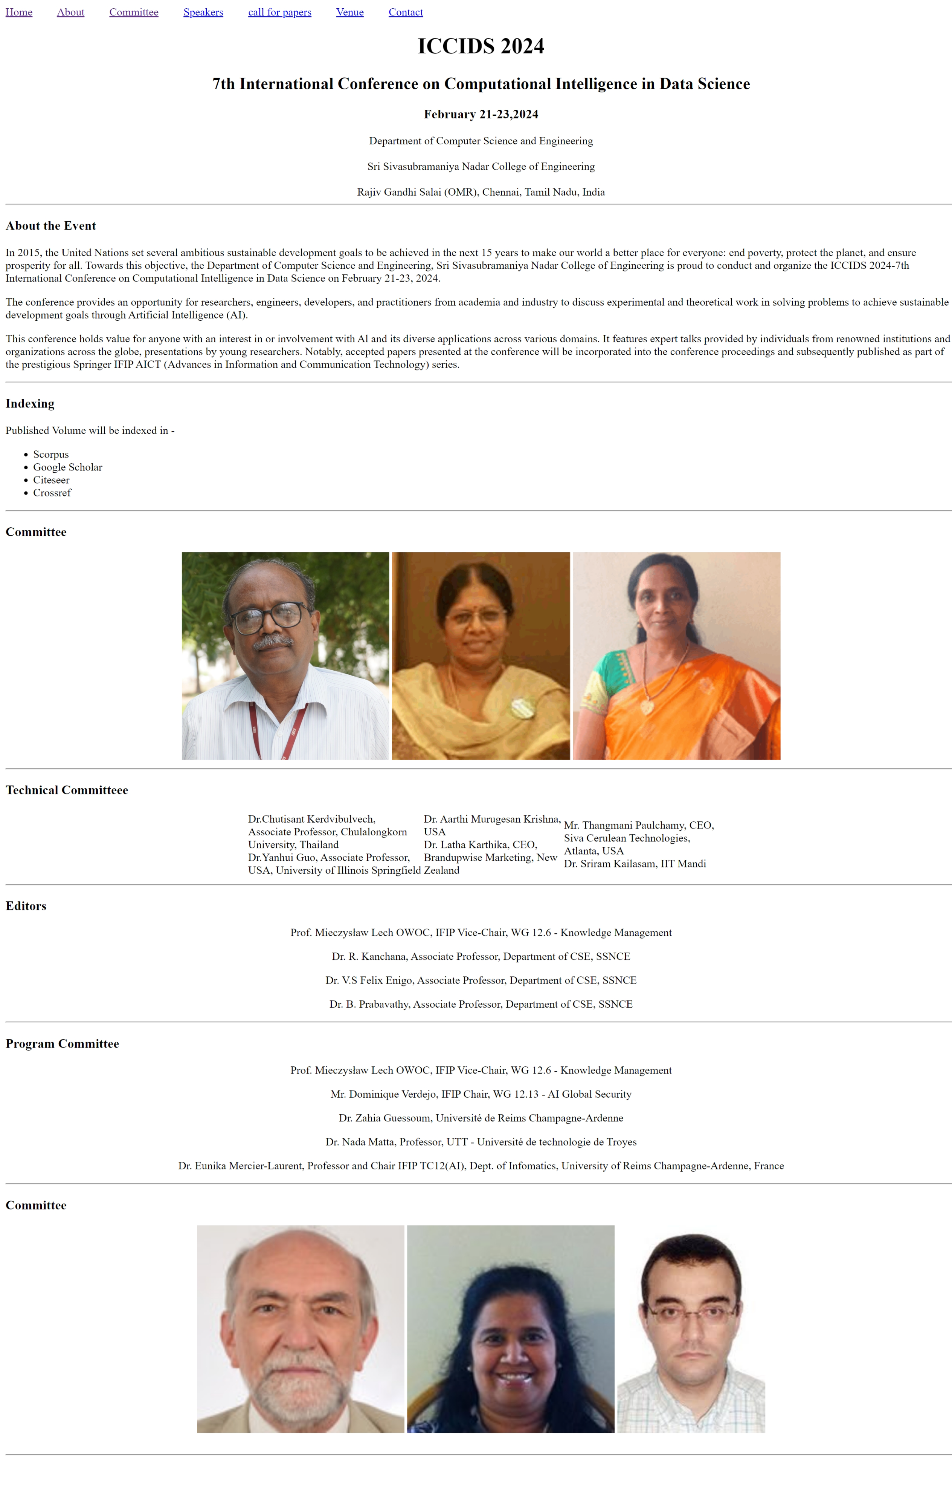

**Home.html**

<!DOCTYPE html>

<html>

    <head>

        <title>Home</title>

    </head>

    <body>

        <p style="color:blue">Home</p>

        <hr>

        Image element

        <center><img src="https://i1.rgstatic.net/ii/profile.image/1109608177369090-1641562613941_Q128/Mieczyslaw-Owoc.jpg" alt="Image"></center>

        <hr>

        bold, emphasize, big, small, <b>SSN College of Engineering</b> <i>SSN College of Engineering SSN College of Engineering</i>

        <br>

        <br>

        SSN College of Engineering

        <hr>

        Table-Example for Cell padding and Cell spacing

        <center>

            <table border="1" cellpadding="10" cellspacing="15">

                <tr>

                    <td>R.No</td>

                    <td>Name</td>

                </tr>

                <tr>

                    <td>1</td>

                    <td>Karthikeyan</td>

                </tr>

                <tr>

                    <td>2</td>

                    <td>Kavin</td>

                </tr>

            </table>

        </center>

        <hr>

        Table - Example for row and column span

        <center>

            <table border="1">

                <tr>

                    <th>Algorithm</th>

                    <th colspan="5">Implementation</th>

                    <th>Viva</th>

                    <th>Total</th>

                </tr>

                <tr>

                    <td>(15)</td>

                    <td>(20)</td>

                    <td>(15)</td>

                    <td>(20)</td>

                    <td>(20)</td>

                    <td>(10)</td>

                    <td>(10)</td>

                    <td>(100)</td>

                </tr>

                <tr>

                    <td>10</td>

                    <td>13</td>

                    <td>10</td>

                    <td>12</td>

                    <td>18</td>

                    <td>10</td>

                    <td>7</td>

                    <td>80</td>

                </tr>

            </table>

        </center>

        <hr>

        <!-- <center> -->

            <fieldset>

                <legend>Date</legend>

                <label for="input1">Day:</label>

                <input type="text" id="date" name="date">

                <label for="input2">Month:</label>

                <input type="text" id="month" name="month">

                <label for="input3">Year:</label>

                <input type="text" id="year" name="year">

            </fieldset>

        <!-- </center> -->

        <hr>

        HTML References

        <center>" ' <> &</center>

        <hr>

        HTML Form Elements

        <br>

        <form action="#">

            <label for="token">Token Number: <input type="text" name="token" id="token"></label><br>

            <label for="name">Name: <input type="name" name="name" id="name"></label><br>

            <label for="mobile">Mobile Number: <input type="mobile" name="mobile" id="mobile"></label><br>

            <label for="email">E-mail Id: <input type="email" name="email" id="email"></label><br>

            Gender:<br>

            <label for="Male">Male<input type="radio" id="m" name="gender"></label>

            <label for="Female">Female<input type="radio" id="fm" name="gender"></label>

            <label for="Transgender">Transgender<input type="radio" id="t" name="gender"></label>

            <br><br>

            Qualification:<br>

            <label for="ug">UG<input type="radio" id="ug" name="qualification"></label>

            <label for="pg">PG<input type="radio" id="pg" name="qualification"></label>

            <label for="ug">MBA<input type="radio" id="mba" name="qualification"></label>

            <br><br>

            No. of Years:

            <select name="no_of_years" id="no_of_years">

                <option value="1">2</option>

                <option value="2">3</option>

                <option value="3">4</option>

                <option value="4">5</option>

            </select>

            <br><br>

            <button type="submit">Submit</button>

        </form>

        <br>

        <a href="ICCIDS.html">Conference Website-ICCIDS</a>

        <br>

    </body>

</html>

**Output:**

